STOURBRIDGE TOWNSHIP COUNCIL
The Neighbourhood Council of Stourbridge, established 1979

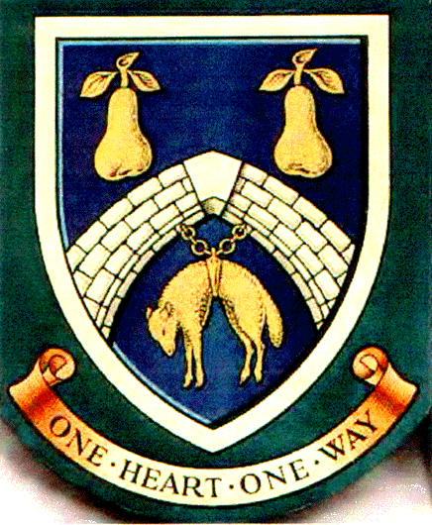

THURSDAY 14TH MAY 2015 FISH AND CHIP SUPPER

Food is being ordered from Oldswinford Fish and Chip Shop.

Mini fish and chips is £3-99
Normal portion is £6-00 (Cod)

For those wanting an alternative see the full menu – see attached link oldswinfordfishandchips.co.uk/

For refreshments, it was suggested at the last meeting that members bring a bottle either to share or hold a raffle.

Partners and friends are welcome.

Plates, cutlery and glasses will be provided.

Payment to be made on the Thursday evening.

Please can you let Kari know by Tuesday evening what you would like to order -email or call on 01384 395552.

